Homework 4– Working with Stacks
Student Name: Andrew Steele
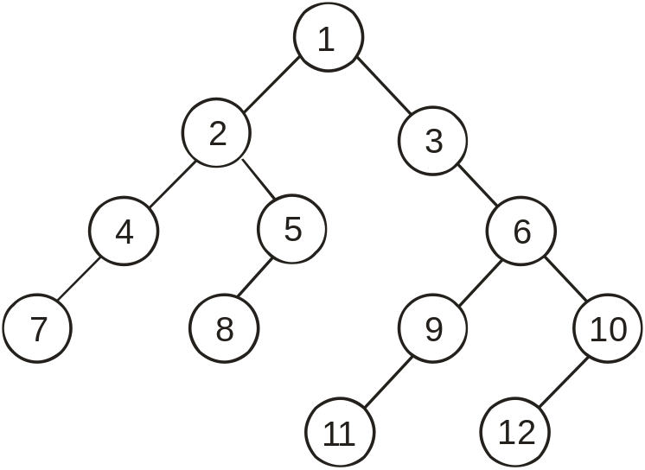
Figure 1
Figure 1 displays a simple binary tree. In a binary tree, each node has, at most, 2 child nodes. Although we have not learned about this data structure yet, code for a SimpleTreeNode has been provided in the Stack Homework project available on Moodle. A SimpleTreeNode contains a value and it also contains refernces to two other SimpleTreeNodes: the left child and right child. So, for example, in Figure 1, the root node has a value of 1 and its left child is the 2 node and its right child is the 3 node. Similarly, the left child of the 2 node is the 4 node and the right child is the 5 node.
Test code has been provided in the TreePrintTester class to create the binary tree shown in Figure 1. This class will create a StackBasedTreePrinter, passing the root node of the tree into the constructor, and will then call the printTree method.
Problem 1a (3 points):
Implement the printTree method in the StackBasedTreePrinter class found in the problem1 package of the code provided on Moodle. This method should print out all of the nodes of the tree exactly once, using a stack implementation, starting with the root node.
- To solve this problem, you will first need to put the root node (passed in via the constructor) onto the stack.
- You then need to implement some type of loop where the first step involves popping an item off the stack and printing it out.
- The remaining steps involve knowing what should be put on the stack next.
- Please note that your code needs to work for any arbitrary binary tree, not just the specific tree shown in Figure 1. That is, I don’t want to just see a bunch of print statements where you hard-code the path from the root node into the print statement. So, for example, I don’t want to see something like this:
System.out.println(getRootNode().getLeftChildTreeNode().getRightChildTreeNode().getLeftChildTreeNode())
- The purpose of this assignment is to get you to think more abstractly about the Stack data structure and how you might employ its LIFO property to be able to efficiently traverse all the nodes in a tree.
Copy and paste your entire printTree method here:
public void printTree(){
SimpleTreeNode<E> nextNode = null;
SimpleTreeNode<E> parentRoot = null;
getStack().push(getRootNode());
while(rootNode.getLeftChildTreeNode() != null || rootNode.getRightChildTreeNode() != null) {
if(nextNode == null)
setRootNode(stack.peek());
else {
setRootNode(nextNode);
nextNode = null;
}

if(rootNode.getLeftChildTreeNode() != null) {
stack.push(rootNode.getLeftChildTreeNode());
}

if(rootNode.getRightChildTreeNode() != null) {
stack.push(rootNode.getRightChildTreeNode());
if(rootNode.getRightChildTreeNode() != null)
nextNode = rootNode.getLeftChildTreeNode();
}

}

int counter = 1;
while(counter < getStack().size()) {
System.out.println(stack.get(counter - 1));
counter++;
}

Problem 1b (1 points):
Copy and paste the output produced when you run the program here:
1
2
3
4
5

Problem 2a (4 points):
Implement the printTree method in the ListBasedTreePrinter class found in the problem2 package of the code provided on Moodle. This method should print out all of the nodes of the tree exactly once, using a list implementation, starting with the root node.
- To solve this problem, you will first need to add the root node (passed in via the constructor) to the list.
- You then need to implement some type of loop where the first step involves printing off the next item in the list. By next, I mean that, if you have already printed off item 0, then the next item would be item 1. If you have already printed off item 1, then the next item would be item 2, etc. (HINT: you will need to keep track of which items in the list you have already printed off and which ones have not been printed yet.)
- The remaining steps involve knowing what should be put on the list next and how to work your way systematically through the list.
- Please note that your code needs to work for any arbitrary binary tree, not just the specific tree shown in Figure 1.
- The purpose of this assignment is to get you to think more abstractly about the List data structure and how you might use it to efficiently traverse all the nodes in a tree.

Copy and paste your entire printTree method here:
public void printTree(){
list.add(getRootNode());
while(getRootNode().getLeftChildTreeNode() != null || getRootNode().getRightChildTreeNode() != null) {
if(getRootNode().getLeftChildTreeNode() != null) {
list.add(0, getRootNode().getLeftChildTreeNode());
}
if(getRootNode().getRightChildTreeNode() != null) {
list.add(0, getRootNode().getRightChildTreeNode());
}
setRootNode(getRootNode().getRightChildTreeNode());
}
int counter = 1;
while(counter < list.size()) {
System.out.println(list.get(counter - 1));
counter++;
}
}
Problem 2b (1 points):
Copy and paste the output produced when you run the program here:

1
2
3
4
5

Problem 2c (1 points):
What is the most obvious difference between the order in which the stack-based approach prints out the nodes versus the list-based approach?

When using an ArrayList you have to start by setting values to the zero index verses using a stack where you push the values onto it from the front.

BONUS QUESTION (2 points)

Create a new project called Maze Traversal and create the Maze, MazeSolver, and MazeTester classes by typing in the code from code listing 4.1, 4.2, and 4.3, respectively, from the Java Software Structures book. Test that the code works by using the MazeTraverseInputFile.txt provided on Moodle as input. All you need to do is copy and pasted the code that YOU TYPED IN (i.e., do NOT get the code from someone else) for all 3 classes and also include the output you get when it runs on the input file provided. Although there may be a few concepts in the code that are new (such as the Deque class), hopefully you will learn a few things by typing it in!

